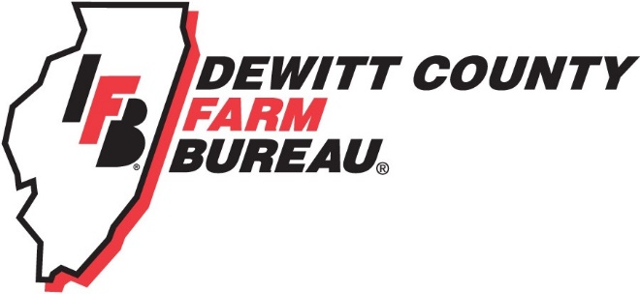

FOR IMMEDIATE RELEASE
February 1, 2019
Contact:
Janell Baum Thomas, DeWitt County Farm Bureau Manager
217-519-2892
dcfb3@frontier.com

Central Illinois Farm Bureaus partner on ag awareness campaign
- Regional Farm Bureaus develop video series to feature top ag issues
- Videos focus on animal welfare, organic farming
CLINTON, ILL. – DeWitt County Farm Bureau has partnered with other area County Farm Bureaus to develop a series of agriculture awareness videos which will appear on social media over the next several months.
The videos will focus on reaching consumers and non-members on the topics of organic and conventional farming and animal welfare. It is a continuation of a previous member-focused campaign which also aimed to answer consumers’ questions about today’s agriculture.
The videos feature local Farm Bureau members from Piatt, Christian, and Moultrie Counties. They can be seen on the Illinois Farm Bureau website at www.ilfb.org/resources/bring-it-home. Local member dues make this messaging possible.
“We hope these short videos will help farmers communicate with non-farmers and provide a glimpse into food and ag issues,” said DeWitt County Farm Bureau President Tom Hieronymus, Farmer City. “We think it provides a great value to our members.”
Illinois Farm Bureau assisted with development of the videos and campaign. For more information, please call the DeWitt County Farm Bureau office at 217-935-2126 or email dcfb3@frontier.com.
-end-

