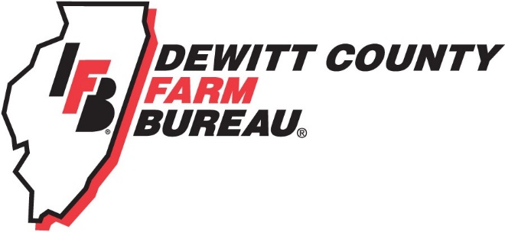

FOR IMMEDIATE RELEASE
January 21, 2020
Contact:
Allison Reinecke, DeWitt County Farm Bureau Manager
608-495-2116
dcfb3@frontier.com

DeWitt County Farm Bureau Foundation offers scholarships for local college, high school students
- Scholarships range in value from $500 to $1,500
- Applications due to DCFB office by March 1
- County residents and/or dependents of DCFB members eligible

CLINTON, ILL. - The DeWitt County Farm Bureau Foundation has opened applications for its 2020 scholarship program.

Five scholarships ranging in value from $500 to $1,500 will be available to college and high school students studying agriculture.

To be eligible for the scholarships, students must either be a current college student enrolled in an ag-related program or a high school senior planning to study in an ag-related field. Students also must either reside in DeWitt County or be the dependent of a DeWitt County Farm Bureau voting member.

Again this year, a $500 scholarship made possible through the Foundation’s Tractor Drive will be available. While all students meeting the above qualifications are eligible to receive this scholarship, individuals planning to begin or continue their tech or trade education will receive bonus points during application evaluation.

Complete eligibility details and the scholarship application can be found on www.dewittcountyfarmbureau.com/scholarships, or by calling the office at 217-935-2126.

Typed applications are due via email or hard copy in the DeWitt County Farm Bureau office, 1060 State Hwy. 54, Clinton, by 6 p.m. on March 1. High school applicants are also asked to participate in an in-person interview on March 9 at the DCFB office.

-end-

