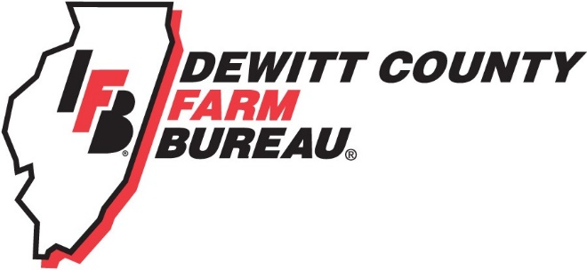

FOR IMMEDIATE RELEASE
August 25, 2017
Contact:
Janell Baum Thomas, DeWitt County Farm Bureau Manager
217-519-2892
dcfb3@frontier.com

Farm Bureau Tractor Drive will tour DeWitt County countryside
- Farm Bureau Tractor Drive includes stop on “Farm Crawl” route
- Drive raises funds for scholarships and ag education materials
CLINTON, ILL. – A parade of tractors will take to the DeWitt County countryside on Sept. 10 as part of the 2017 DeWitt County Farm Bureau Tractor Drive.
The drive, which raises funds for the DeWitt County Farm Bureau Foundation, will depart the 4-H Fairgrounds in Clinton at 8 a.m. on Sunday morning and travel about 40 miles before returning to the grounds around 4 p.m.
Participation in the drive is open to the public, and the cost to participate is $50. Entry fee includes lunch, entry into the grand prize drawing, a drivers’ gift, and a commemorative souvenir photo. Complete details and a drive map are on the DeWitt County Farm Bureau website, www.dewittcountyfarmbureau.com.
“We enjoy sponsoring this activity because it is a great time of the year to get out and enjoy the first bit of fall before it’s time for harvest and everything speeds up,” said Randy Toohilll, event chairperson. “This also allows us to support our scholarship fund with the [Farm Bureau] Foundation and encourage students from our area to continue their studies in agriculture.”
The drive route includes four lake crossings and covers much of the central part of the County. It also includes a stop along the DeWitt County Farm Crawl route, which also takes place on Sept. 10, from 10 a.m. to 5 p.m. Details about the Farm Crawl, which is a free event with on-farm activities for parents and children, are at www.dewittcountyfarmcrawl.com.
Drivers’ families and the public are encouraged to meet the tractors either at the lunch stop, Triple M Farm, or on the Clinton Square, where they will “parade” past before finishing the route. Tractors are scheduled to arrive at Triple M Farm between 12 p.m. and 1 p.m., and at the square between 3 p.m. and 4 p.m.
Several area businesses have generously supported the Farm Bureau Tractor Drive, including AHW, Inc., Altorfer, Inc., Anderson Ford, Baum Chevrolet Buick, Central Illinois Ag, Douglas Dodge Ram, Farm Credit Services, and Snappers Bar & Grill.
Registrations for the drive are requested by Sept. 4. Questions about the drive can be directed to DeWitt County Farm Bureau at 217-935-2126.
-end-

