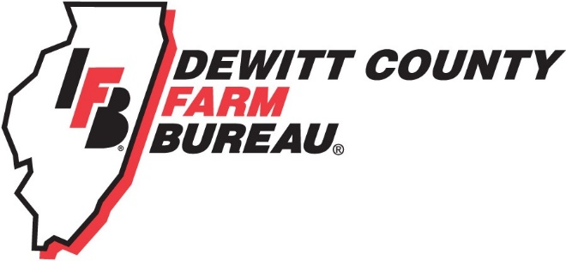

FOR IMMEDIATE RELEASE
March 5, 2018
Contact:
Janell Baum Thomas, DeWitt County Farm Bureau Manager
217-519-2892
dcfb3@frontier.com

First responders, farmers invited to electrical safety training
Electrical safety training scheduled for March 15
‘Live Line’ Demonstration inspires safety around power lines
- Electrical demonstration includes a full-scale power line
- Training hours available for first responders
- Farmers, first responders and road commissioners invited to enjoy dinner before presentation
CLINTON, ILL. – DeWitt County first responders, road commissioners and Farm Bureau members are invited to dinner and an electrical safety demonstration on March 15 at the DeWitt County Highway Building, 9900 Revere Rd., Clinton.
Dinner is scheduled for 5:30 p.m. and the program will begin at 6 p.m. RSVPs are requested no later than Monday, March 12. The featured speaker is Corn Belt Energy’s Steve Hancock, who will bring along a full-scale power line to demonstrate the power of electricity and how that can translate into serious issues if met with large equipment or other obstructions.
The demonstration, which is expected to last about two-and-a-half hours, may count for continuing education credit and is certified through McLean County Area EMS. If this applies to you, please check with your safety officer.
According to Hancock, attendees will learn everything they need to know for escaping an electrical accident safely, using electricity in the home, properly managing electrical panels, managing overhead and underground lines, plowing ditches safely, proper tree trimming around lines and more.
Hancock also will address outages and how they occur, and explain distribution systems. Discussion on the lasting effects of an electrical burn is on the agenda as well.
Hancock, who started in the utility industry more than 42 years ago, has been with Corn Belt Energy for the last four years. He said each demonstration is different, and even those who have seen a demonstration before always come away from the training with another piece of information they didn’t know before.
The training is an exciting, informative presentation with a full-scale power line. It is organized by DeWitt County Farm Bureau and supported by a Country Financial and Illinois Farm Bureau farm safety grant.
For more information regarding the seminar, and to register, please call the DeWitt County Farm Bureau office at 217-935-2126 or email dcfb3@frontier.com. Area fire, police and EMS departments are welcome to register as a group.
-end-

Cutline: Steve Hancock, Corn Belt Energy, leads an informative and exciting Live Line Demonstration for first responders. (Corn Belt Energy photo)

