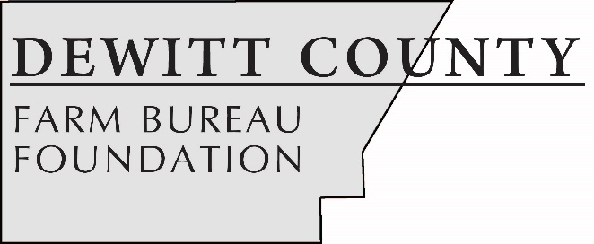

FOR IMMEDIATE RELEASE
January 15, 2019
Contact:
Janell Baum Thomas, DeWitt County Farm Bureau Manager
217-519-2892
dcfb3@frontier.com

DeWitt County Farm Bureau Foundation offers scholarships for college, high school students
- Scholarships range in value from $500 to $1,500
- Applications due in DCFB office by March 1
- County residents and/or dependents of DCFB members eligible
CLINTON, ILL. – The DeWitt County Farm Bureau Foundation has opened applications for its 2018 scholarship program. Five scholarships ranging in value from $500 to $1,500 will be available to college and high school students studying agriculture.
Typed applications are due via email or hard copy in the DeWitt County Farm Bureau office, 1060 State Hwy. 54, Clinton, by 4 p.m. on March 1. High school applicants are also be asked to participate in an in-person interview on March 11 at the DCFB office.
To be eligible for the scholarships, students must either be a current college student enrolled in an ag-related program or a high school senior planning to study in an ag-related field. Students also must either reside in DeWitt County or be the dependent of a DeWitt County Farm Bureau voting member.
A $500 scholarship made possible through the Foundation’s Tractor Drive also will be available. While all students meeting the above qualifications are eligible to receive this scholarship, individuals planning to begin or continue their tech or trade education will receive bonus points during application evaluation. Examples include, but are not limited to: welding, diesel mechanics and truck/trailer operation.
Complete eligibility details and a copy of the application can be found on www.dewittcountyfarmbureau.com/scholarships, or by calling the office at 217-935-2126.
-end-

