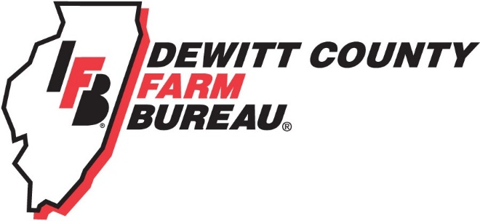

FOR IMMEDIATE RELEASE
March 25, 2020
Contact:
Allison Reinecke, DeWitt County Farm Bureau Manager
608-495-2116
dcfb3@frontier.com

Farm Bureau urging farmers, agriculture industry to donate surplus masks
CLINTON, ILL.- Due to a national strain on our healthcare system due to COVID-19, there is currently a shortage of medical personal protective equipment, specifically N95 masks. DeWitt County Farm Bureau is calling upon farmers, grain elevators, construction companies, union laborers, and individuals who use these masks as PPE, to donate any surplus new/unused masks.
The DeWitt County Farm Bureau is participating in F.A.R.M. for Health, which stands for Farmers and Ranchers Masks for Health. This is a campaign in coordination with numerous county Farm Bureaus across the state of Illinois to ensure that our rural healthcare workers have proper supplies and PPE during this pandemic.
“Farmers, ag workers use those N95 masks to clean out grain bins and work in conditions with less than ideal air quality around the farm. We are hoping that individuals and businesses will check their shops, offices, and farm trucks to collect any surplus, unused masks,” says manager, Allison Reinecke. “We’ll be working with the DeWitt Piatt Bi-County Health Department to make sure that those masks are distributed where they are needed locally.”
A collection box is located just outside the front entrance of the DeWitt County Farm Bureau office, 1060 IL-54, Clinton, where individuals can drop off their unused masks any time.
Due to the shelter in place order, DCFB asks that individuals drop off masks if they feel the trip is considered essential travel. For a full list of participating drop off locations or any other information, visit Farm4Health on Facebook, or email farm4health@outlook.com.
For more information, please contact DeWitt County Farm Bureau at 217-935-2126 or email dcfb3@frontier.com.
-end-

