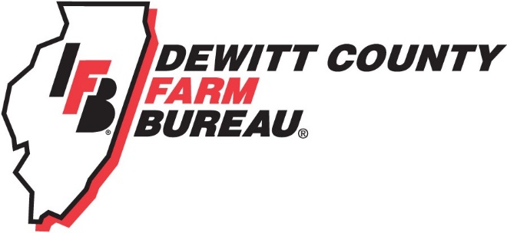

FOR IMMEDIATE RELEASE
August 15, 2018
Contact:
Janell Baum Thomas, DeWitt County Farm Bureau Manager
217-519-2892
dcfb3@frontier.com

Farm Bureau Tractor Drive will tour DeWitt County countryside
- Farm Bureau Tractor Drive begins and ends at Kenney
- Drive raises funds for scholarships and ag education materials
CLINTON, ILL. – A parade of tractors will take to the DeWitt County countryside on Sept. 8 as part of the 2018 DeWitt County Farm Bureau Tractor Drive.
The drive, which raises funds for the DeWitt County Farm Bureau Foundation, will depart the Farmer’s Grain Elevator and Excel Railcar Grounds in Kenney at 12 noon on Saturday, and travel about 26 miles before returning to Kenney at about 5:30 p.m.
Participation in the drive is open to the public, and the cost to participate is $35. Entry fee includes a fried chicken dinner served by the Kenney Fire Department, door prizes, and commemorative souvenir photos. Complete details and a drive map are on the DeWitt County Farm Bureau website, www.dewittcountyfarmbureau.com/tractordrive.
Along the route, drivers will enjoy a train underpass, a creek ford, several bridge crossings. The drive also begins and ends during the Kenney Fall Festival, which takes place on Sept. 7-8, 2018. Activities include a hypnotist, performance by the Clinton M-Squad, and concerts from 7-9 both Friday and Saturday nights, in addition to vendor displays.
Drivers’ families and the public are encouraged to greet the tractors along the route or meet them at the Fall Festival.
“We enjoy sponsoring this activity because it is a great time of the year to get out and enjoy the first bit of fall before it’s time for harvest and everything speeds up,” said Randy Toohilll, event chairperson. “This also allows us to support our scholarship fund with the Farm Bureau Foundation and encourage students from our area to continue their studies in careers that serve our area ag industry.”
Last year, proceeds from the drive funded a Tractor Drive Scholarship. Students entering an agriculture field are eligible to apply, although first preference will be given to candidates intending to study or currently studying a vocational trade. Some examples include but are not limited to: welding, diesel mechanics, or electrical contracting. Applications for the next round of scholarships will be accepted in early Spring 2019.
Several area businesses have generously supported the Farm Bureau Tractor Drive, including AHW, Inc., Anderson Ford, Baum Chevrolet Buick, Central Illinois Ag, Douglas Dodge Ram, and Farm Credit Services.
Registrations for the drive are not required, but are appreciated by Sept. 5. Questions about the Drive can be directed to DeWitt County Farm Bureau at 217-935-2126.
-end-

